OpenMV Motor Shield.

Features

  - TB6612 driver.
  - Controls up to 2 DC motors.
  - Built-in thermal shutdown circuit.
  - Low voltage detecting circuit.
  - CW/CCW/short brake/stop function modes.
  - Low standby current.
  - Operating supply voltage range of 6 V to 9 V.

Description

The Motor Shield enables OpenMV cameras to control up to 2 motors. It features the TB6612 DC motor driver with built-in thermal shutdown circuit and low voltage detecting circuit. The OpenMV software and IDE includes scripts for controlling this shield.

Device Information
PART NUMBER | BODY SIZE (NOM)
OPENMV-MOTOR-SHIELD | 1.40 in × 1.05 in

Applications

- Self-driving cars.
- Controlling actuators.

.
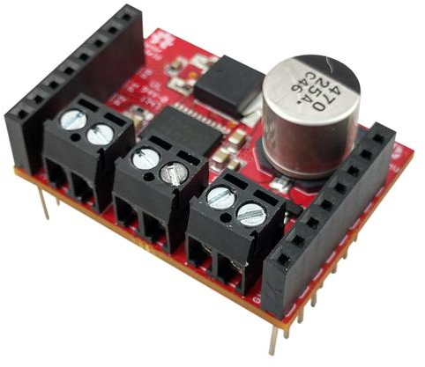

Table of Contents
1 Features 1
2 Description 1
3 Applications 1
4 Pin Configurations and Functions 3
5 Electrical Characteristics 4
5.1 Recommended Operating Conditions 4
6 Mechanical Information 5

Pin Configurations and Functions

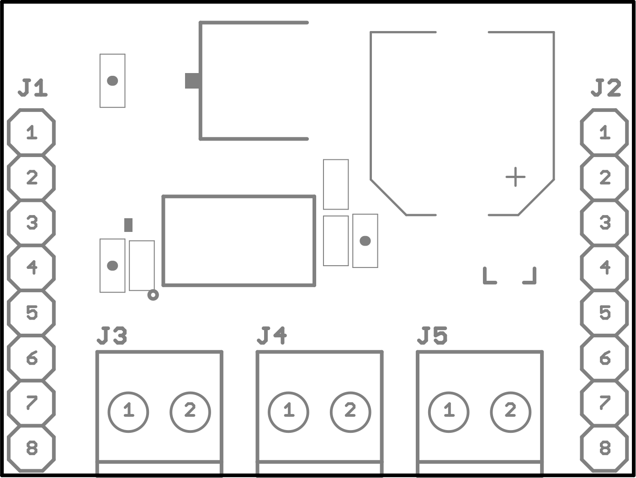

Pin Functions
Pin |  |  | Description
Header | No | Name | Description
J1 Pin Configuration
J1 | 1 | P0 | Channel B input 2
J1 | 2 | P1 | Channel B input 1
J1 | 3 | P2 | Channel A input 2
J1 | 4 | P3 | Channel A input 1
J1 | 5 | P4 | NC
J1 | 6 | P5 | NC
J1 | 7 | P6 | TB6612 Standby (Active low).
J1 | 8 | 3v3 | TB6612 input supply (3.3v)
J2 Pin Configuration
J2 | 1 | RST | NC
J2 | 2 | BOOT | NC
J2 | 3 | SYN | NC
J2 | 4 | P9 | NC
J2 | 5 | P8 | PWM channel B speed control input
J2 | 6 | P7 | PWM channel A speed control input
J2 | 7 | VCC | Regulator output supply (5v/2000mA)
J2 | 8 | GND | GND
J3 Pin Configuration
J3 | 1 | A1 | Channel A output 1
J3 | 2 | A2 | Channel A output 2
J4 Pin Configuration
J4 | 1 | B2 | Channel B output 2
J4 | 2 | B1 | Channel B output 1
J5 Pin Configuration
J5 | 1 | GND | GND rail.
J5 | 2 | VBAT | Regulator input (6v-9v)

Electrical Characteristics

5.1 Recommended Operating Conditions

SYMBOL | RATINGS | MIN | MAX |  | UNIT
V_{bat} | Regulator input supply voltage range. | 6.0 | 9.0 |  | V
V_{3v3} | TB6612 input supply voltage range. | 2.7 |  | 5.5 | V
I_{out} | External output supply current range. |  |  | 2000 | mA
T | Operating Temperature | -40 | 85 |  | °C

Mechanical Information
The following information is the most current data available for the designated device. This data is subject to change without notice and without revision of this document.

